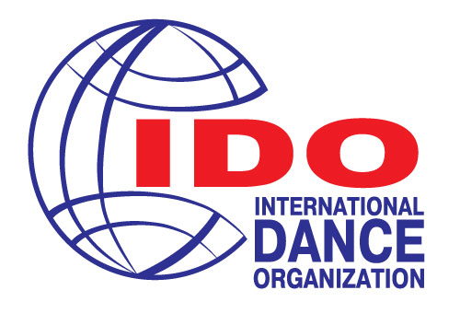
International Dance Organization
All Russia Dance Organization
Presenting:
VII Baltic Dance OLYMPIAD
18-20 October 2019
Russian Federation, Saint-Petersburg
ACCOMODATION AND VENUE
Hotel «Saint-Petersburg»
Pirogovskaya emb. 5/2,
Saint-Petersburg
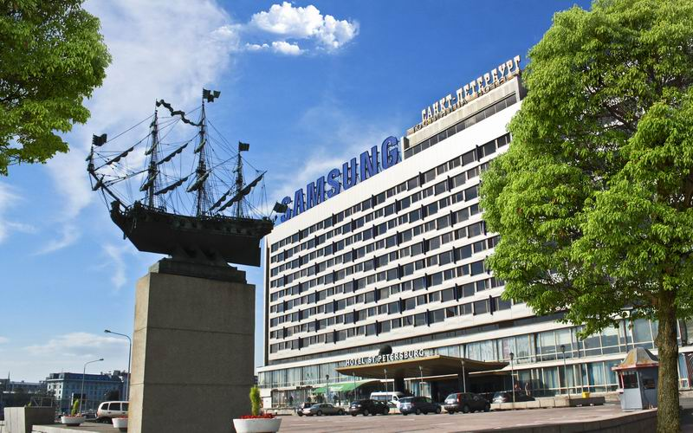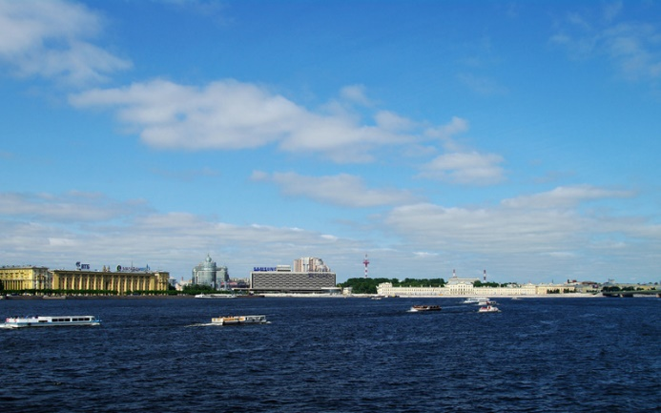
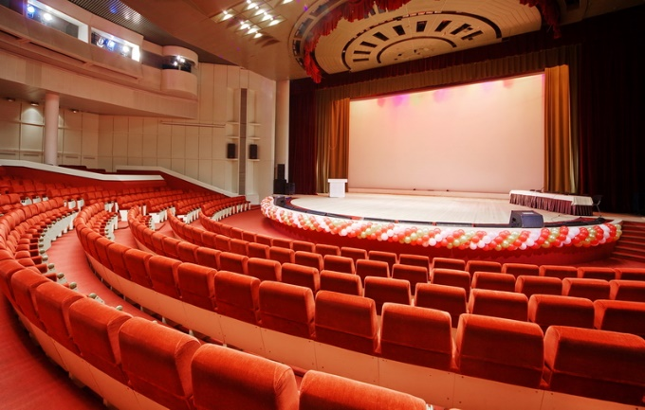

Welcome to Saint-Petersburg Hotel
The Saint-Petersburg Hotel is located in the historical center of the city, on the main Neva River Embankment and is suitable for all kinds of visitors, both leisure and business. In addition, we pride ourselves on offering the best view of the St. Petersburg historical city center.
Rated 3 Star, the Saint-Petersburg Hotel, aims at providing great value at an affordable price. We also aim to please you with our friendly and personalized service.
We are just a few meters from the famous Aurora Battle Cruiser and the Peter and Paul Fortress, both of which you can see from our rooms. The Hotel Saint-Petersburg, named after the city, offers easy access to all tourist attractions, the State Hermitage Museum, the Russian Museum, the Mikhaylovsky Castle, the Summer Garden, the Mariinsky Theatre and many, many more.
Our location is not only ideal for tourism, but also for business. Close to our hotel we have a large number of the city's business regions and main road arteries, metro, trains and public transport. It is therefore easy to use our hotel and facilities for exhibitions, conferences and conventions, receptions and banquets. We have 1450 square meters of meeting and exhibition space and a magnificent 1405 square meter, column-free, Grand Concert Hall. We offer up-to-date technical equipment for all our meeting space and everything we do and have should contribute to making your event a successful one. Hotel is the no smoking area.
Our tasty buffet breakfast is served in our main all-day dining restaurant, called the 'Bering', the breakfast is included in all our room prices. You can also enjoy a drink or a light meal in our Lobby Bar. The beverage selection should have something for everyone's desire.

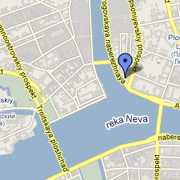
Room facilities:
- Phone line
- Satellite television
- Personal washing composition
- Wi Fi Internet access is free of charge in any room.
Hotel facilities:

- Reception 24 hours
- Storage baggage room
- Safety box
- Courier service
- Concierge service
- Booking
- Parking
- ATM
- Exchange service
- Taxi and transfer service
- Internet access
- Internet terminal
- Souvenir shop
- Laundering and ironing service

SPECIAL prices!!!
Rooms  (with breakfast) | Special offer from the organizer (Per Room, Eur) | Special offer from the organizer (Per person, Eur)
Single room Standard  (faced to Neva river) | 60 | 60
Double room Standard  (faced to Courtyard) | 70 | 35
Deluxe (2+2 sofa)  (faced to Courtyard) | 108 | 27
Deluxe (2+2 sofa)  (faced to Neva river) | 125 | 31
Additional bed | 20 | 20

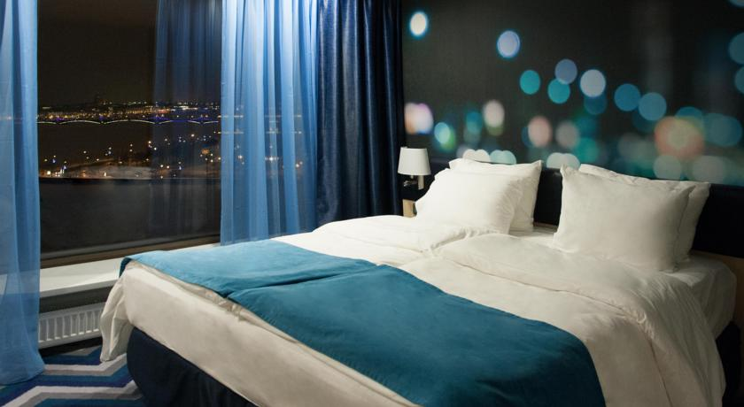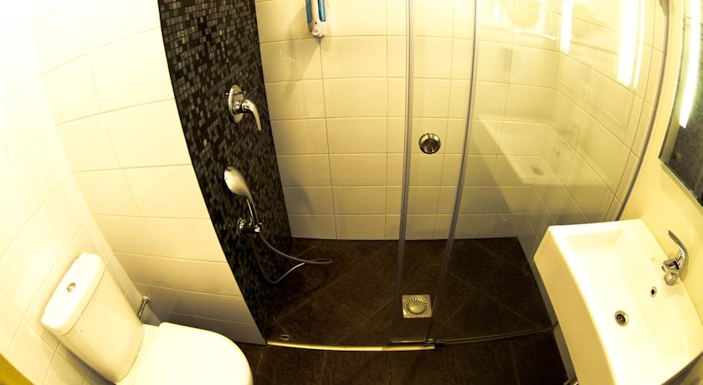

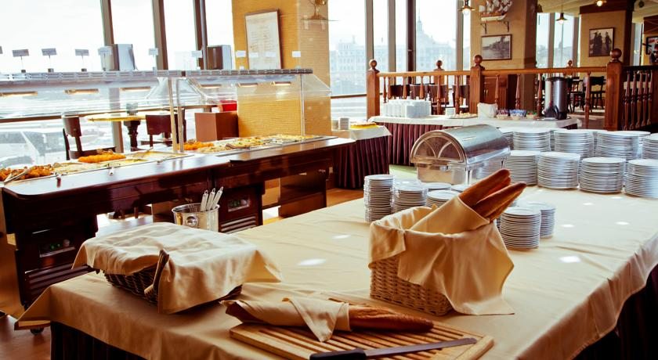
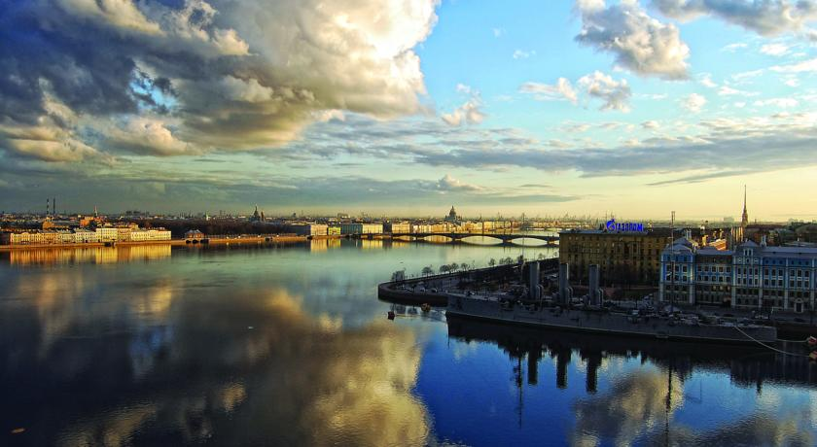

«Empire Park Hotel»
Lebedev street, 10g, metro station "Ploshchad Lenina"
Saint-Petersburg

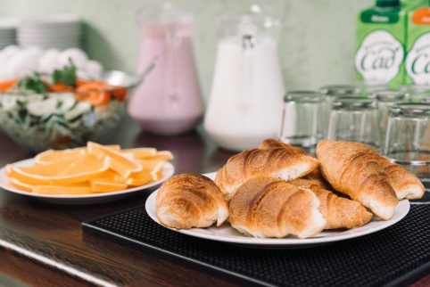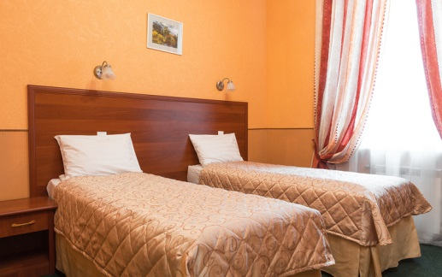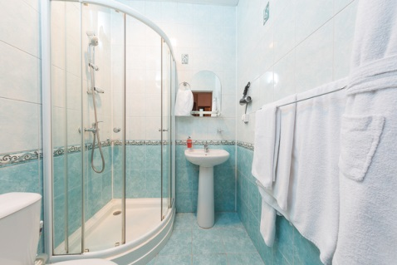

Room facilities:
- Phone line
- Satellite television
Wi Fi Internet access is free of charge in any room.
Hotel facilities:

- Reception 24 hours
- Storage baggage room
- Safety box
- Booking
- Parking
- Taxi and transfer service
- Internet access
- Laundering and ironing service

Rooms  (with breakfast) | Special offer from the organizer (Per Room, Eur) | Special offer from the organizer (Per person, Eur)
Double room Standard | 60 | 30
Double room Deluxe | 70 | 35

«Grand Memories Hotel»
Ulitsa Kuybysheva 5, Saint-Petersburg
Gorkovskaya metro station is quickly reachable. 20 km to Pulkovo airport

The hotel is steps away from Military Historical Artillery Museum featuring soundproof rooms with a mini bar, a balcony, a work desk, panoramic windows and hi-fi. It features airport shuttle bus service, 24-hour front desk assistance and housekeeping service as well as a safety deposit box and an elevator.
This property is 20 minutes' walk to State Hermitage Museum and Winter Palace. The city center lies within 2 km from the venue.
Nearby points of interest include a museum and a church.
Rooms come with the city view.

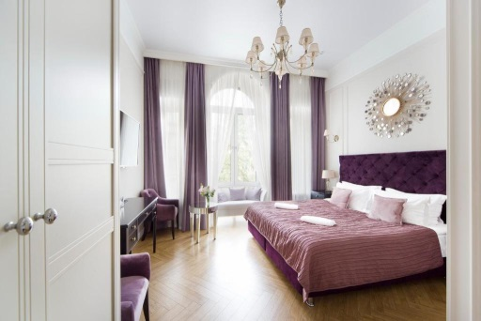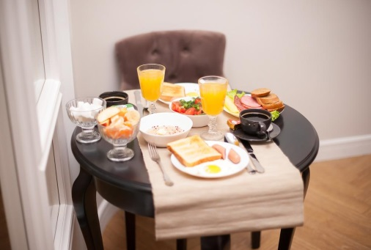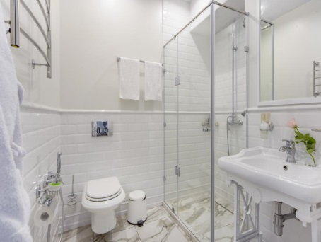

Rooms  (with breakfast) | Special offer from the organizer (Per Room, Eur) | Special offer from the organizer(Per person, Eur)
Double room Standard | 70 | 35
Double room Deluxe | 80 | 40
Hotel facilities:
Non-smoking rooms ,Lift ,Safe deposit box ,Wi-Fi, 24-hour reception ,No pets allowed , Off-site car park, No smoking on site, Bridal suite
Meals & Beverages:
In-room breakfast, Electric kettle
Services:
Room service, Fax/Photocopying, Housekeeping, Shops/Commercial services,Rooms come with
Heating,Dressing area , Air conditioning , Soundproofed rooms ,Free toiletries,Mini-bar,
Flat-screen TV ,Parquet floor, Sitting area

Deadline for accommodation is 15 of September!

Contacts:
- Accommodation, transfer, meals – Elena Makarova evm2019@mail.ru or elenavbrr@yandex.ru
- Invitation for visa - Elena Makarova evm2019@mail.ru or elenavbrr@yandex.ru

Application form for accommodation
Name of the team:
Country:
Contact person:
Phone:
E-mail:

Surname, first name | Date of Arrival | Date of departure | Type of room | Number of rooms | Number of persons
Ivanova Irina  Ivanov Ivan | 13.10 | 15.10 | Double room Standard | 1 | 2
TOTAL |  |  |  | 1 | 2

* If you need an early arrival or late departure, please register separately
(Early check-in before 12:00 am - 100% of the room per day;
late check-out until 18:00 - 50% of the room per night, after 18:00 - 100%)

MEALS
Breakfast Is included in accommodation
Lunch (buffet) and Dinner (buffet) cost 10 Euro each
Please contact Elena Makarova evm2019@mail.ru

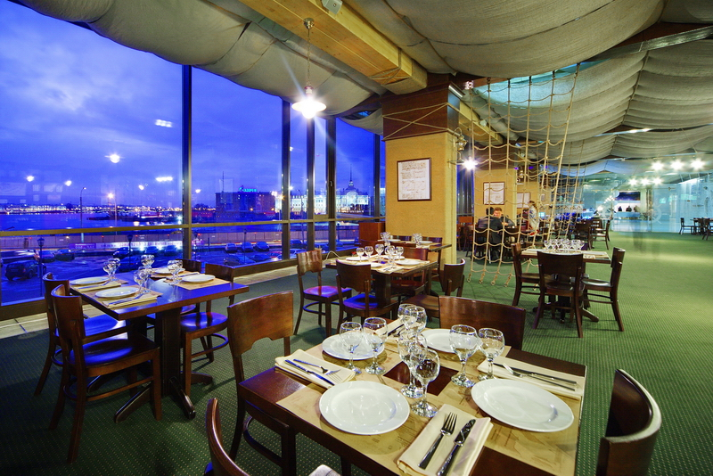
Panoramic restaurant “Bering” offers its guests a wide variety of original beer, brewed in own brewery and a great choice of beer snacks, pizzas and hot dishes! Boiled crayfish, pork shank and other culinary masterpieces would impress each connoisseur of delicious food!
Restaurant is located on a “B” floor and has a panoramic view for the historical center of Saint-Petersburg. You can feel the spirit of the city without even leaving the hotel!
Restaurant has all kinds of professional video and audio equipment, even the light show, plasma panels set all over the hall broadcast football matches and other sporting events.
Free Wi-Fi makes the place comfortable for both work and leisure.
Accommodation of every category includes exquisite buffet.
Every day, from 1 pm till 3 pm “Bering” becomes a buffet restaurant and offers a wide variety of salads, hot dishes of meat and fish, soups etc.

TRANSFER
Transfer Airport / Railway Station - Hotel / one way
Bus (Volvo, Mercedes, Scania) - 110 Euros (40- 53 pers.)
Mini Bus (Mercedes Sprinter, Viano) - 90 Euros (max 18 pers.)
The car economy class- 45 Euros (3 pers. max), upon request
The car Premium- 55 Euros (3 pers. max), upon request
The night hours from 00-00 till 6 a.m. – extra payment

Apply for transfer application Please contact Elena Makarova evm2019@mail.ru

 |  | There | Back
Name of Team/  Contact person/  Phone number/mail | NEW CENTRO DANZE CARAMIA 3388946243
Country | ITALY
Where to pick up (name of the airport, railway station, hotel) |  | PULKOVOTERMINAL 1 | Hotel “Saint-Petersburg”
Where to go |  | Hotel  “Saint-Petersburg” | PULKOVO TERMINAL 1
Date |  | 12/10/18 | 17/10/18
Time  Number Flight / train |  | TIME 17:50 p.m FLIGHT AZ 5248 | TIME 09:20 a.m FLIGHT AZ 7213
Number of persons |  | 5 | 5

TICKET
700 rub or 10 euro per day

Invitation: Please contact Elena Makarova evm2019@mail.ru
Registration: IDO web site www.ido-dance.com through IDO member organizations.
Deadline – 15 of SEPTEMBER
Final Schedule: Will be published after registration on the web site
Day by day Schedule see in another document
Organizer’s office: ardo.06@mail.ru +7-925-772-60-51, 10.00 – 18.00 Moscow time

We will be glad to see you in S. Petersburg for the IDO outstanding championship!!
